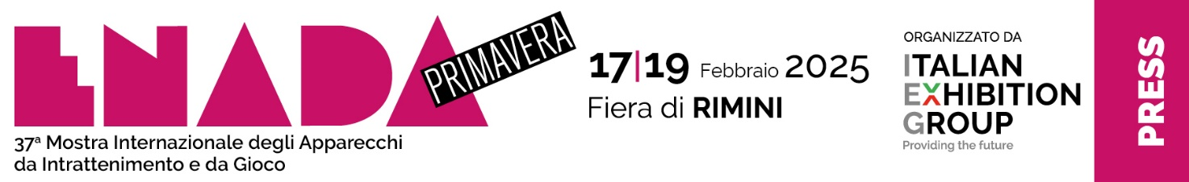

press release no. 4

ENADA, THE ECONOMIC SNAPSHOT OF THE GAMING INDUSTRY

The gaming, sports betting, and lottery sector still on the rise in 2024.

Rimini, 30 January 2025 - The gaming, sports betting, and lottery sector remains unshaken by crises. Despite some differences between categories, it has continued to grow in 2024.

According to preliminary data from the Monopolies, covering the first three quarters of 2024, last year's sports betting revenue was 5.4 billion euros, a 5.9% increase on 2023. Meanwhile, spending rose by 2.6%, reaching 954.5 million euros. Naples, Rome, and Milan are the provinces with the highest share of in-person betting.

Online gaming has consistently maintained its popularity, gaining traction during the pandemic period due to the restrictions that forced agencies to close for an extended period. This trend has persisted, with bettors continuing to embrace this digital gaming experience.
Last year, online gaming generated a revenue of approximately 14.3 billion euros, a significant 28.8% increase compared to the previous year's 11.1 billion.
Meanwhile, spending slightly surpassed €1.6 billion, a 6.7% increase from the €1.5 billion in 2023.

The rise of online gaming is causing a slight decline in physical gaming. In 2023, compared to 2019, 7,300 fewer AWP-hosting venues were monitored, a decrease of 13,500 units.
On the other hand, the VLT network remains steady, with a slight decrease in the number of establishments (529 fewer) offset by a larger size.

Lotteries have seen significant growth: Lotteria Italia 2024 sold 8.6 million tickets, a significant increase from 6.7 million in 2023 (+29.3%), representing a total investment of 43.3 million euros.

Regarding the various types of gambling, the data available up to September 30, 2024, show (in millions of euros):
- Gaming machines – revenue: 21,603.68; winnings: 16,157.11
- Sports Betting – Total Bets: 20,653.08; Total Winnings: 18,261.52
- Numerical Games and Lotteries – Collection: 16,731.17; Winnings: 11,915.73
- Other games – Collection: 53,861.81; Winnings: 51,352.01

(Source: Italian Monopolies and Customs Agency)

ABOUT ENADA 2025
Date: 17-19 February 2025; organiser: Italian Exhibition Group S.p.A., in collaboration with SAPAR; edition: 37th; recurrence: annual; info: https://www.enada.it/

ABOUT RAS 2025
Date: 17-19 February 2025; organiser: Italian Exhibition Group S.p.A., in collaboration with SAPAR; edition: 7th; recurrence: annual; info: https://www.riminiamusement.it/

PRESS CONTACT ITALIAN EXHIBITION GROUP
head of media relation & corporate communication: Elisabetta Vitali; press office manager: Marco Forcellini, Pier Francesco Bellini; international press office coordinator: Silvia Giorgi; press office coordinator: Luca Paganin; press office specialist: Nicoletta Evangelisti, Mirko Malgieri: media@iegexpo.it

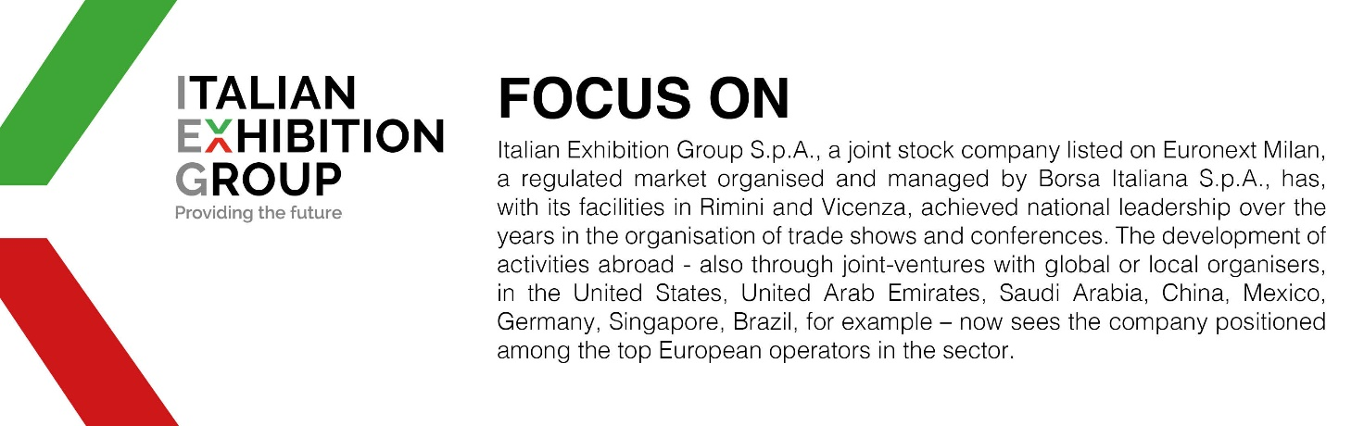

This press release contains forecast elements and estimates that reflect the management’s current opinions (“forward-looking statements”), particularly regarding future management performance, realization of investments, cash flow trends and the evolution of the financial structure. For their very nature, forward-looking statements have a component of risk and uncertainty, as they depend on the occurrence of future events. The effective results may differ (even significantly) from those announced, due to numerous factors, including, only by way of example: food service market and tourist flow trends in Italy, gold and jewellery market trends, green economy market trends; the evolution of raw material prices; general macroeconomic conditions; geopolitical factors and evolutions in the legislative framework. Moreover, the information contained in this release does not claim to be complete, and has not been verified by independent third parties. Forecasts, estimates and objectives contained herein are based on the information available to the Company as at the date of this release.

